TRIAL 1

explain format =tree

select l.city, r.region_name, c.country_name, l.location_id

from locations l inner join countries c on l.country_id = c.country_id

inner join regions r on r.region_id = c.region_id

where c.country_name in ('india','brazil');

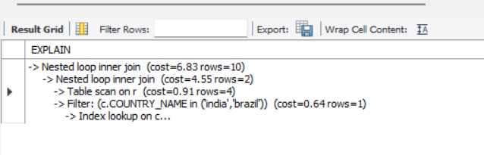

TRIAL 2 – REPLACING IN WITH = REDUCED COST

explain format=tree

select l.city, r.region_name, c.country_name, l.location_id

from locations l inner join countries c on l.country_id = c.country_id

inner join regions r on r.region_id = c.region_id

where c.country_name = 'india' or c.country_name = 'brazil';

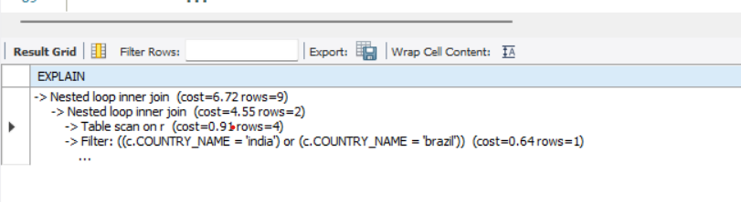

TRIAL 3 – ON FORCING REGION PRIMARY INDEX COST IS INCREASED HENCE OPTIMISER IGNORED IT

explain format=tree

select l.city, r.region_name, c.country_name, l.location_id

from locations l inner join countries c on l.country_id = c.country_id

inner join regions r force index(primary) on r.region_id = c.region_id

where c.country_name = 'india' or c.country_name = 'brazil';

-- PARTITION TABLE based on salary

create table range_part_1sal (employee_id int ,

first_name varchar(20),

last_name varchar(20),

salary int

)

partition by range(salary)

(

partition p_5k values less than (5000),

partition p_10k values less than (10000),

partition p_15k values less than (15000),

partition p_20k values less than (20000)

);

insert into range_part_1sal select employee_id, first_name, last_name, salary from employees;

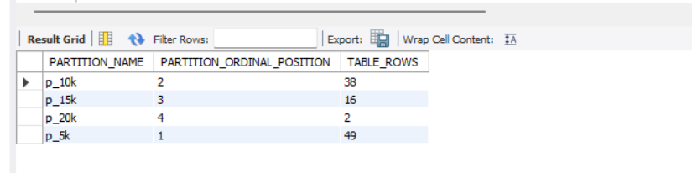

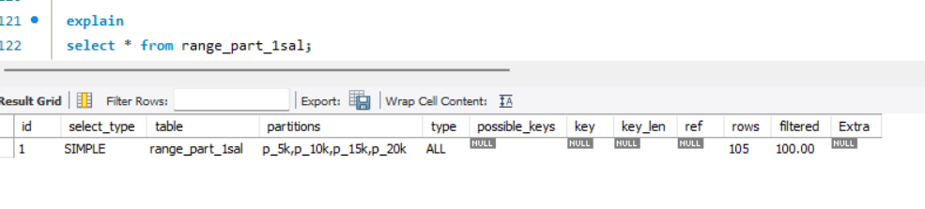

**d**

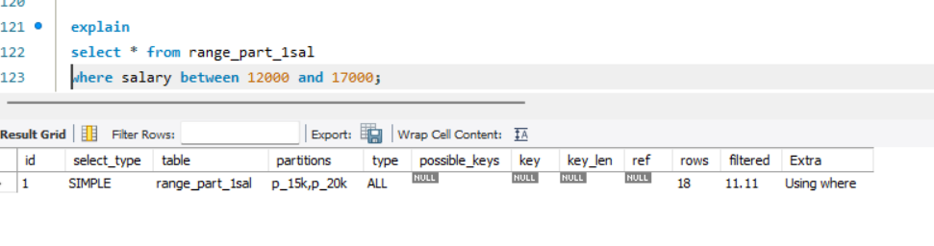

Partitions used are p_15k and p_20k as the values between 12000 and 17000 falls in that partitions

**e**

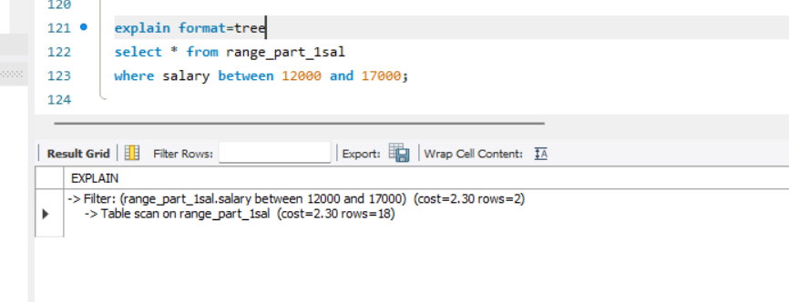

Here table scan is done on 18 rows only as there are 16 rows in p_15k and 2 rows in p_20k

**F**

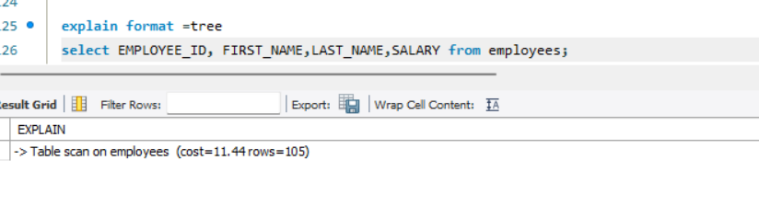

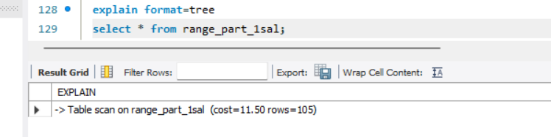

Here there is not much cost difference in above two. But we are fetching rows based the range of salary, cost will differ drastically.

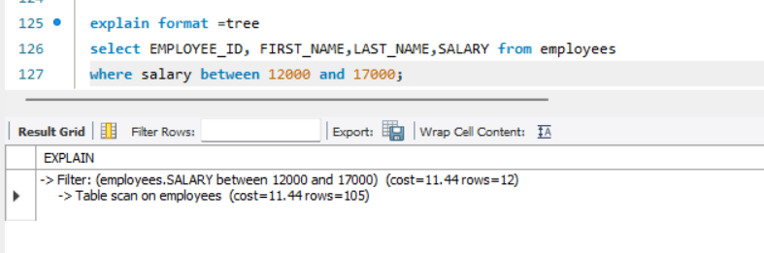

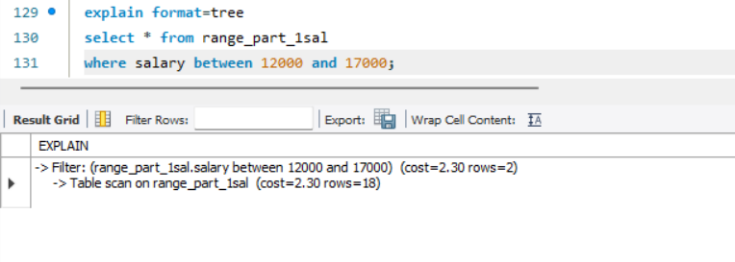

Here we can see that in employees table cost is 11.44 where as in range_part_1sal(partition table) it is 2.30. so partition table reduced the cost.

**G**

**In question C, we created a partition table range_part_1sal which contains 4 partitions (p_5k, p_10k, p_15k, p_20k) based on the range of salary specified. So rows will be partitioned into these partitions based on partition the salary belongs to.**

**In question D, we have fetched the rows with salary between 12000 and 17000 . on explaining the query we can see that table scan is done only on 2 partitions which contains the specified range of salary which is p_15k an dp_20k. therefore the total number of rows scanned is also reduced to 18 and reduced cost as well. Without using partition table this will require a table scan on whole table which is highly expensive. So partition table improves the efficiency.**